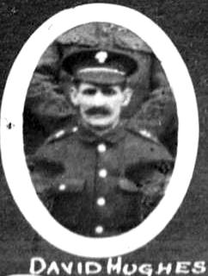
14. David. Hughes. 1st Battalion Welsh Guards.

Name: HUGHES, Initials: D, Rank: Private, Service No: 259
Regiment/Service: Welsh Guards, Unit Text: 1st Bn.
Date of Death: 27/12/1916, Age: 40
Additional information: Son of Richard and Ann Hughes, of Vron, Llangollen; husband of Margaret Hughes, of Mount Pleasant, Vron, Llangollen, Denbighshire.
Grave/Memorial Reference: II. E. 19. , Cemetery: Bronfay Farm Military Cemetery, Bray-Sur-Somme

1881 19, Trefynant, Trevor Isaf, Llangollen
Richard Hughes Head M 32(1849) Clay Miner Llangollen Denbighshire Wales
Ann Hughes Wife M 28(1853) Llangollen Denbighshire Wales
David Hughes Son S 4(1877) Llangollen Denbighshire Wales
Margaret A. Hughes Dau S 2(1879) Llangollen Denbighshire Wales
William Hughes Son S 1(1880) Llangollen Denbighshire

1891Vron, Vroncysyllte
Richard Hughes Head M 42(1849) Gen lab Llangollen Denbighshire Wales
Ann Hughes Wife M 38(1853) Llangollen Denbighshire Wales
William Hughes Son S 12(1879) Scholar Llangollen Denbighshire Wales
Sarah E Hughes Dau S 10(1881) Scholar Llangollen Denbighshire Wales
George Hughes Son S 8(1883) Scholar Llangollen Denbighshire Wales
Richard Hughes Son S 3(1888) Scholar Llangollen Denbighshire Wales
George Griffiths Lodg S 33(1858) Collier Llangollen Denbighshire Wales
David Griffiths Son S 15(1876) Gen Lab Llangollen Denbighshire Wales

1911 Brynffynon Vroncysyllte Llangollen
Richard Hughes Head M 61(1850) Quarry Man Denbighshire
Ann Hughes Wife M 58(1853) M 35 Years 10 c 3d Denbighshire
Richard Hughes Jun Son S 23(1888) Collier Denbighshire
Maurice W Hughes Son S 18(1893) Collier Denbighshire
Essey Hughes Son S 16(1895) Collier Denbighshire
Nellie Wynne Niece S 14(1897) Denbighshire

