18. David. Thomas. 1st Battalion West Yorkshire Regiment.
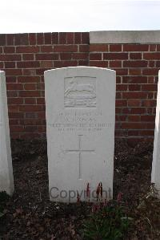
Name: THOMAS, DAVID, Rank: Lance Corporal, Service No: 54541
Regiment/Service: West Yorkshire Regiment (Prince of Wales's Own), Unit Text: 1st/7th Bn.
Date of Death: 01/11/1918, Age: 33
Grave/Memorial Reference: IV. B. 2., Cemetery: Auberchicourt British Cemetery

