1. Edward Davies. 24th Battalion Royal Welsh Fusiliers.
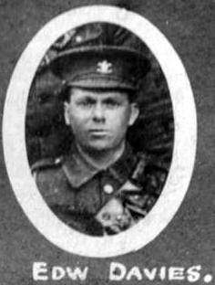
Name: DAVIES, Initials: E, Rank: Sergeant, Service No: 345092
Regiment/Service: Royal Welsh Fusiliers, Unit Text: 24th (509 Denbighshire Yeomanry) Bn.
Date of Death of wounds 28/12/1917 in Egyptian theatre
Grave/Memorial Reference: C. 15.,Cemetery: Jerusalem War Cemetery, Israel
Possible 1911 Tynewydd Farm, Vroncysyllte
Kenrick Davies head M 57(1854) Farmer & Carter Trefnant, Ruabon
Mary Elizabeth Davies wife M 51(1860) M 31 y 7ch 0Dead Llanrahaid y Mochnant
Anne Davies dau S 28(1883) Farmer’s d work on farm Vroncysyllte
Edward Davies son S 25(1886) Farmer’s s work on farm Vroncysyllte
Thomas Davies son S 21(1890) Farmer’s s work on farm Vroncysyllte
Margaret Ellen Davies dau S 16(1895) Apprentice Dressmaker Vroncysyllte
William Kenrick Davies son S 14(1897) Vroncysyllte

