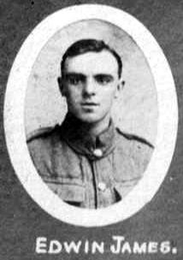
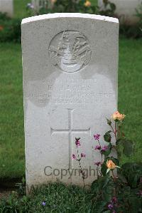
Edwin James. 21st Battalion Royal Welsh Fusiliers.

Edwin James was born in Llangollen January 1896, son of Edward James, of Swan Terrace, Vroncysyllte a labourer in a brickworks, and Mary Jane James (nee Thomas). Edwin became a farm labourer, an was living in Roadside Cottage, Vron when he enlisted at Wrexham on 20th November 1915. Initially he was a private, 29455 in the Bantam Battalion. After training he embarked from Southampton for France on 1st June 1916, where on the 10th July he was attached to the 119th Brigade of signallers. He had two weeks of leave in January 1918 (8th – 22nd). On 6th April 1918 he was transferred, in the field, to the 9th Battalion (Duke of Wellington’s own) West Riding Regiment. He was killed in action between 17th and 21st September, the death was announced officially on the 21st September. He was buried in grave IIA19, Villers Hill British Cemetery, Viller-Guislain, Nord, France.

private
29455 Bantam Battalion
B 1896, Roadside cottage, Vron; Farm labourer, 19y 10m on enlistment, 20/11/1915, Wrexham, Baptist, next of kin Edward James Pen y craig, Vron, mother:- Mary Jane James
Brother: Fred James 28
Sisters:- M C Roberts, 25, Manchester, Margaret Jones, 20 Pen-y-craig, Vron
24/6/1919

embarked Southampton 1st June 1916
10/7/1916 att 119th Brigade signallers, France, leave 8/1/1918 to 22/1/1918
transferred to 26871 9th Battalion (Duke of Wellington’s own) West Riding Regiment
in field 6/4/1918
Killed in action18/9/1918 17/21/9/1918
Buried, II.A.19. Villers Hill British Cemetery, Villers-Guislain, Nord
Officially 21st September

1901 1 Swan Terrace, Vroncysyllte
Edward James head M 34(1867) Lab in brickworks Chirk
Mary J James wife M 34(1867) Llangollen
Frederick James son S 10(1891) Llangollen
Mary C James dau S 7(1894) Llangollen
Edwin James son S 5(1896) Llangollen
Margaret James dau S 3(1898) Llangollen

1911 Brynffynon, Vroncysyllte
Edward James head M 44(1867) Carter Chirk, Denbigh
Mary Jane James wife M 44(1867) M 20 y 4ch Llangollen
Margaret James dau S 13(1898) Llangollen

Mary Catherine was a servant at Pentre Farm, Ruabon.

