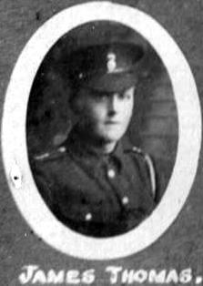
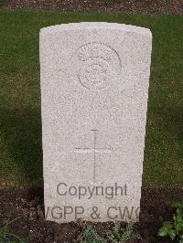
James Thomas. 4th Battalion Royal Welsh Fusiliers.

James Thomas was born in Pontcysyllte in 1895, the son of William Thomas, a coal miner of Woodlands, Pontcysyllte, and Elizabeth Thomas (nee Evans). In 1911 the family were in Bryn View, and in 1915 in Min-y-graig. James, like his three older brothers, followed his father’s occupation, and was a coal miner in 1911. He joined the army as private 7613, and served in D Company 1st/4th Battalion Royal Welsh Fusiliers. On the 19th September 1915 his company were doing pioneering work between the British and German trenches, being continually under fire, when James Thomas was struck by a piece of shrapnel. The injuries were fatal, and he died, aged 19. James Thomas was described as “being most capable and promising” in a letter from the Lieutenant in charge of the party, He was buried in grave I A 21, Noeux-Les Mines Communal Cemetery, Pas de Calais, France

Private 7613, D Coy 1st/4th Battalion Royal Welsh Fusiliers died 19th September 1915, aged 19. buried grave I A 21, Noeux-Les Mines Communal Cemetery, Pas de Calais, France.
Son of William Meredith Thomas and Elizabeth Thomas of Min-y-graig, Fron Cysyllte, Llangollen

1901 Woodlands, Pontcysyllte
William Thomas Head M 35(1866) Coal Miner, Hewer Ruabon
Elizabeth Thomas wife M 35(1866) Llangollen
Frederick Thomas son S 13(1888) Ruabon
Robert W Thomas son S 12(1889) Chirk
William M Thomas son S 10(1891) St Martin’s
David Thomas son S 8(1893) Llangollen
James Thomas son S 5(1896) Llangollen
1911 Bryn View, Vroncysyllte
William Thomas head M 46(1865) Coal Miner Llangollen
Elizabeth Thomas wife M 46(1865) M 24y 10ch Llangollen
Robert Thomas son S 21(1890) Coal Miner Llangollen
William M Thomas son S 19(1892) Coal Miner Llangollen
David Thomas son S 17(1894) Coal Miner Llangollen
James Thomas son S 15(1896) Coal miner Llangollen
Herbert Thomas son S 13(1898) Llangollen
Grace A Thomas dau S 10(1901) Llangollen
Thomas H Thomas son S 8(1903) Llangollen
Gennor A Thomas dau S 6(1905) Llangollen
Perris G Thomas son S 4(1907) Llangollen

24th September 1915
LLANGOLLEN MAN KILLED IN ACTION.
PROMISSING YOUNG PRIVATE’S DEATH. LIEUTENANT DARLINGTON’S TRIBUTE.
Official intelligence reached his parents at Vroncysyllte, yesterday (Thursday), that Pte, James Thomas, 4th Batt. Royal Welsh Fusiliers, has been killed in action in France. Some days ago the sad information reached Mr. Ralph Darlington, Plas Teg, Llangollen, from his son, Lieut. George Darlington, in whose company deceased served, but he “held back” the news pending official confirmation, which is now to hand. It appears the company, under Lieut. Darlington, were doing pioneer work between the British and German trenches, being continually under fire, when deceased, who was only 19 years of age, was struck by a piece of shrapnel, the injuries proving fatal. Lieut. Darlington, in a letter to his parents, speaks of the young soldier as “being most capable and promising” and his last letter written home from the trenches in France constitutes a vigorous recruiting call to the young men of military age at Cefn to do their duty.

