John. Henry. Williams. 9th Battalion Royal Welsh Fusiliers.

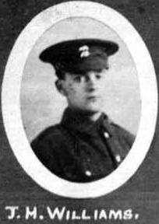
Name: WILLIAMS, JOHN HENRY, Rank: Private, Service No: 24633
Regiment/Service: Royal Welsh Fusiliers, Unit Text: 9th Bn.
Date of Death: 03/07/1916, Age: 18
Additional information: Son of Mrs. Ann Davies, of White House, Vron, Llangollen, Denbighshire.
Grave/Memorial Reference: Pier and Face 4 A., Memorial: Thiepval Memorial Somme

