Lloyd Jones. 4th Battalion Royal Welsh Fusiliers.
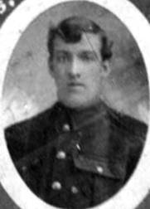
Name: JONES, Initials: L, Rank: Private, Service No: 7602
Regiment/Service: Royal Welsh Fusiliers
Unit Text: 4th Bn.
Date of Death: 07/06/1915
Grave/Memorial Reference: IV. C. 88.
Cemetery: Bethune Town Cemetery, Pas de Calais, France
Possible?
1911 Tynewydd, Vroncysyllte
Job Jones head Wid 66(1845) Road Man Llangollen
JaneAstle dau M 37(1874) 2ch Vron
Lloyd Jones son S 19(1892) Collier brake man Vron
Ernest Jones son S 14(1897) Vron
George Astle g/son S 10(1901) Vron
Nora Astle g/dau S 5(1906) Vron
Wife was Catherine b 1839

