Richard Francis Jones 8th Battalion Welsh Guards.

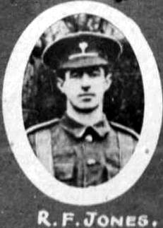
Name: JONES, RICHARD FRANCIS, Rank: Private, Service No: 3560
Regiment/Service: Welsh Guards, Unit Text: 1st Bn.
Date of Death: 01/12/1917
Grave/Memorial Reference: Panel 3., Memorial: Cambrai Memorial, Louverval

