Richard. Hughes. 9th Battalion Royal Welsh Fusiliers.

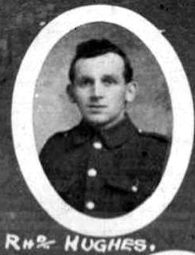
Name: HUGHES, RICHARD, Rank: Private, Service No: 15817
Regiment/Service: Royal Welsh Fusiliers, Unit Text: 9th Bn.
Date of Death: 17/11/1916
Grave/Memorial Reference: Pier and Face 4 A., Memorial: Thiepval Memorial Somme

Possible 1911 Brynffynon, Vroncysyllte
Richard Hughes Head M 61(1850) Quarry man Denbighshire
Ann Hughes wife M 58(1853) M 35y 10ch 3 dead Denbighshire
Richard Hughes Jun son S 23(1888) Collier Denbighshire
Maurice W Hughes son S 18(1893) Collier Denbighshire
Esery Hughes son S 16(1895) Collier Denbighshire
Nellie Wynne niece S 14(1897) Denbighshire

1891 Vron
Richard Hughes head M 42(1849) Gen Lab Llangollen
Ann Hughes wife M 48(1853) Llangollen
William Hughes son S 12(1879) Scholar Llangollen
Sarah E Hughes dau S 10(1881) Scholar Llangollen
George Hughes son S 8(1883) Scholar Llangollen
Richard Hughes son S 3(1888) Scholar Llangollen
George Griffiths lodg S 33(1858) Collier Llangollen
David Griffiths son S 15(1876) Gen Lab Llangollen

