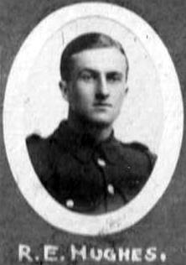
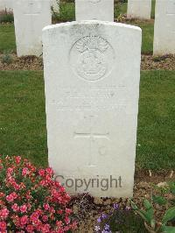
Robert Evan Hughes. 13th Battalion Royal Welsh Fusiliers.

Robert Evan Hughes was born 1895 in Vroncysyllte, son of Evan Hughes a coachman, living in Canal Terrace, Vroncysyllte, and Annie Hughes (nee Jones). In 1901 the family were living in the Vroncysyllte Police Station, and Evan was a gardener. They had moved to back to Canal Terrace by 1911, by which time Evan was a bailiff, and Robert Evan was a chemical worker. Robert Evan joined the Royal Welsh Fusiliers, Service No. 16600. By 1918 he had become Company Quartermaster with the 13th Battalion. He died 22nd April 1918, and was commemorated at G19, Bouzincourt Ridge Cemetery, Albert Somme, France.

Name: HUGHES, ROBERT EVAN, Rank: Company Quartermaster Serjeant, Service No: 16600
Regiment/Service: Royal Welsh Fusiliers, Unit Text: 13th Bn.
Date of Death: 22/04/1918, Age: 24
Additional information: Son of Mr. and Mrs. Evan Hughes, of 1, Canal Terrace, Vroncysyllte, Llangollen.
Grave/Memorial Reference: II. G. 19., Cemetery: Bouzincourt Ridge Cemetery, Albert Somme

1901 Police Station, Vroncysyllte
Evan Hughes head M 39(1862) Gardener Cerrig Y Druidion Denbighshire
Annie Hughes wife M 37(1864) London
Edward Hughes son S 16(1885) ? Packer Trefnant, Denbighshire
William Hughes son S 13(1888) Tile Polisher Llangollen
Hilda Hughes dau S 11(1890) Llangollen
Jennie Hughes dau S 8(1893) Llangollen
Robert Hughes son S 6(1895) Llangollen
Mabel Hughes dau S 3(1898) Llangollen
Kenny M Jones board S 26(1875) Police Constable Abergele
Fred Edwards board S 26(1875) ? Manager Pontrillo, Mont
1911, Canal Terrace, Vroncysyllte
Evan Hughes Head M 49(1862) Bailiff Cerrig Y Druidion Denbighshire
Annie Hughes Wife M 47(1864) M 27 8c London
William Hughes Son M 23(1888) Chemical Worker Denbighshire Vronsycyllte
Lizzie Hughes D-I-L M 19(1892) M <1 Black Park Denbighshire
Robert E Hughes Son S 17(1894) Chemical Worker Denbighshire Vroncysyllte
Annie Mabel Hughes Dau S 13(1898) Denbighshire Vroncysyllte
Grace Hughes Dau S 8(1903) Denbighshire Vroncysyllte
Bertha Lake Hughes Dau S 6 (905) Denbighshire Vroncysyllte

Jq 1884 Evan Hughes m Annie Jones, Corwen
1891 Evan Hughes a coachman, Canal Terrace, Llangollen

