Robert Jones. 1st Battalion King’s Own Yorkshire Light Infantry.
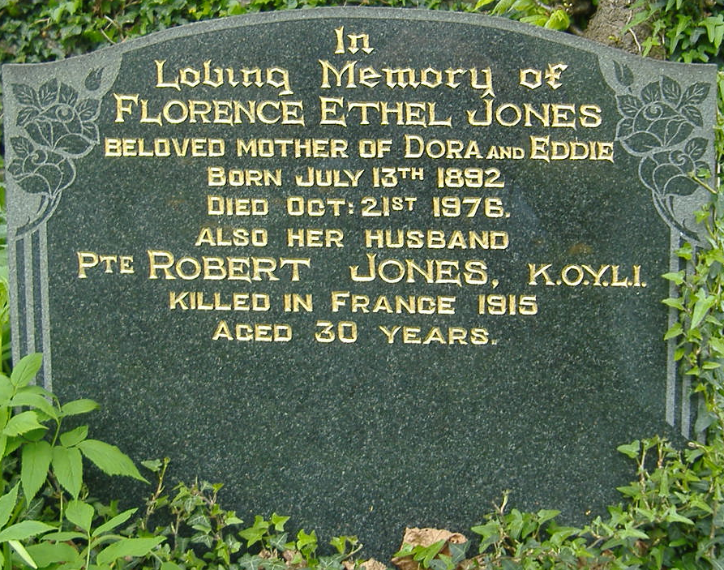
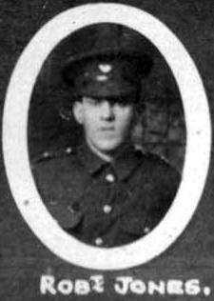
Name: JONES, ROBERT, Rank: Private, Service No: 14243
Regiment/Service: King's Own Yorkshire Light Infantry, Unit Text: 1st Bn.
Date of Death: 08/05/1915
Grave/Memorial Reference: Panel 47
Cemetery: Ypres (Menin Gate) Memorial
B 1885

