William. Roberts. 4th Battalion Royal Welsh Fusiliers.

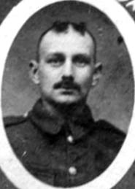
Name: ROBERTS, Initials: W, Rank: Private, Service No: 203408
Regiment/Service: Royal Welsh Fusiliers, Unit Text: "B" Coy. 4th Bn.
Date of Death: 26/08/1917, Age: 36
Additional information: Son of William and Annie Roberts.
Grave/Memorial Reference: I. L. 5., Cemetery: Belgian Battery Corner Cemetery

Name: ROBERTS, WILLIAM, Rank: Private, Service No: 201005
Regiment/Service: Royal Welsh Fusiliers, Unit Text: 4th Bn.
Date of Death: 06/04/1918, Age: 20
Additional information: Adopted son of John Griffiths, of 130, Ruabon Rd., Rhostyllen, Wrexham, Denbigh.
Grave/Memorial Reference: VI. D. 53., Cemetery: Doullens Communal Cemetery Extension No.1 Somme

Name: ROBERTS, Initials: W, Rank: Private, Service No: 200608
Regiment/Service: Royal Welsh Fusiliers, Unit Text: 4th Bn.
Date of Death: 17/03/1917
Grave/Memorial Reference: Enclosure No.4 I. E. 11.
Cemetery: Bedford House Cemetery

