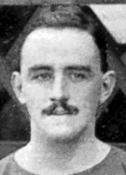
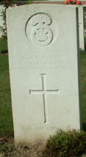
13. George Oliver Thomas
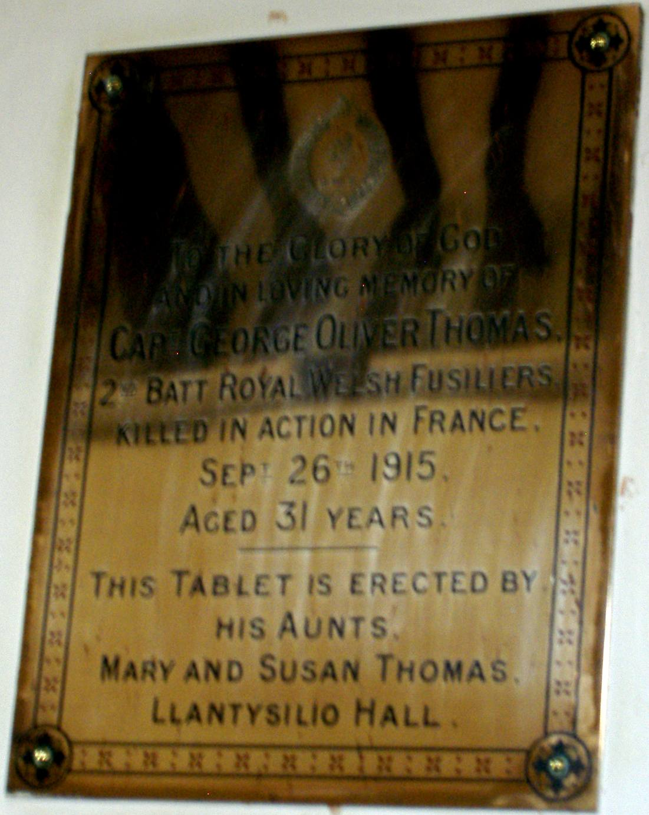
George Oliver Thomas was born in Calcutta, 1885, the second son of George Edmunds Thomas, who was a merchant with J. Thomas & Sons, Tea Merchants, of Calcutta, and Marion Adelaide Thomas ( nee Ross). His grandfather Thomas Thomas of Llandrinio, Montgomeryshire had been a farmer of 300 acres. After his grandfather’s death George’s uncles John and William, and aunts Mary, Susan Elizabeth and Fanny leased Llantysilio Hall from Sir Henry Beyer Robertson, who had moved to Palé on the death of his father. George and his elder brother Thomas Edmund often stayed in Llantysilio with their aunts when they were home from India, and George was well known for his polo and cricket in North Wales. Whilst Thomas became a merchant in Calcutta like his father, George joined the Royal Welch Fusiliers. In 1911 George was stationed in Roberts barrack, Quetta Balochistan, India, (now Pakistan) with the 2nd Battalion, while Thomas was with the aunts in Llantysilio. In September 1913 Thomas Married Jean Robertson, daughter of Sir Henry Beyer Robertson at Llandderfel. At the outbreak of war George and his regiment were still in India, they were brought back and deployed at Flanders, where, with the exception of two short periods of leave in Llangollen, he served his time until killed in action 26th September 1915, aged 31. He was buried in grave K 21, Cambrin Churchyard extension, Pas de Calais, France

Llantysilio Hall was bought in 1873 by Charles Frederick Beyer, who had it completely rebuilt in 1875. On his death in 1876 he bequeathed it to his godson, Sir Henry Beyer Robertson. It remained with the Robertson family until sold to a private buyer for £300,000 in 1994. On the death of his father, Henry Robertson in 1888 Henry acquired Palé, and he leased out Llantysilio Hall. By 1901 it was occupied by John Thomas,
Llangollen Advertiser
8th October 1915
Great regret has been caused at Llangollen by the announcement of the death of Capt. George Oliver Thomas, R.W.F., second son of the late Mr. Geo. E. Thomas, of Calcutta, who was killed in action, in France, on September 26th. He was the second son of the late George E. Thomas, and of Mrs. Thomas of “Hermon”, Farnham Surrey, and was 31 years of age. He was with his regiment in India at the outbreak of war. He proceeded in Flanders, where, with the exception of two brief periods of leave at Llangollen, the last six weeks ago, he had been ever since. He was well-known in North Wales as a cricket and polo player. His brother, Lieut. Thomas of Ystrad, Llangollen, is with the Montgomery Yeomanry.
Wisden: Obituaries, 1915. Capt. George Oliver Thomas (2nd Battalion Royal Welsh Fusiliers) who was killed in Flanders on September 27, aged 31, was well-known in North Wales as a cricketer.
George Oliver Thomas, Captain , 2nd Battalion, Royal Welsh Fusiliers, died 26th September 1915, aged 31, K 21, Cambrin Churchyard extension, Pas de Calais, France
son of Mrs George E Thomas, of 610, Clive Court, Maida Vale, W.G., and the late George E. Thomas (of Messs J. Thomas and Co Calcutta)
1881 Beech House, Ellesmere
Thomas Thomas Head Wid 73(1808) Retired Farmer Llandrinio Montgomeryshire
Mary Thomas Dau S 43(1838) Llandrinio Montgomeryshire
Susan E. Thomas Dau S 41(1840) Llandrinio Montgomeryshire
George E. Thomas Son S 32(1849) Calcutta Merchant Llandrinio Montgomeryshire
Jane Rhodes Niece Wid 36(1845) Annuitant Llansainfraid Montgomeryshire
Ann Jones Serv S 25(1856) Cook Llanfyllin Montgomeryshire
Mary Ann Jones Serv S 25(1856) Housemaid Ellesmere Shropshire
Elizabeth Barlow Serv S 17(1864) Housemaid Ellesmere Shropshire
Ellis Vaughan Serv S 21(1860) Groom (Dom) Wem
(George Edmund Thomas b Llanfyllin MQ 1848)
1901 Llantysilio Hall, Llantysilio
John Thomas Head S 60(1841) Living on o m Llandrinio Montgomeryshire
Mary Thomas Sister S 64(1837) Llandrinio Montgomeryshire
Susan Elizabeth Thomas Sister S 62(1839) Llandrinio Montgomeryshire
Fanny Thomas Sister 58(1843) Llandrinio Montgomeryshire
William Lloyd Thomas Bro M 55(1846) Living on o m Llandrinio Montgomeryshire
Ada Thomas S-i-L M 43(1858) Calcutta
Jane Rhodes Cous Wid 58(1843) Llansanffraid Montgomeryshire
Robert G D Thomas Cous S 24(1877) Living on o m Brentwood Essex
James J Radcliffe Serv S 29(1872) Butler Shortlands Kent
Wm Richard Ottley Serv S 23(1878) Footman Basingstoke Berkshire
Jane Ann Ottley Serv S 29(1872) Cook Penrith Westmorland
Agnes Balls Serv S 33(1868) Maid Norwich Norfolk
Alice Wilkes Serv S 31(1870) H’maid Broseley Shropshire
Sarah Jane Evans Serv S 21(1880) H’maid Leighton Shropshire
Alice Povey Serv S 24(1877) Laun maid Haines Hill Berkshire
Alice Dorothy Jones Serv S 23(1878) Kitchen maid Newtown Montgomeryshire
Frances A Thompson Serv S 18(1883) Scullery m Newcastle Upon Tyne
1911 Llantysilio Hall Llantysilio Llangollen
Mary Thomas Head S 70(1841) Private Means Llandmes Montgomeryshire
Susan E Thomas Sister S 69(1842) Private Means Llandmes Montgomeryshire
Thomas E Thomas Neph S 28(1883) Private Means Calcutta
Alice Churcher Serv S 42(1869) Cook Sevenoaks Kent
Agnes Balls Serv S 43(1868) Lady’s Maid Norwich
Sarah Jones Serv S 32(1879) Laundry Maid Alberbury Shopshire
Alice Roberts Serv S 32(1879) Housemaid Market Drayton Shopshire
Florence Davies Serv S 22(1889) Kitchen Maid Weston Rhyn Denbigh
Annie G Griffiths Serv S 20(1891) Scullery Maid Northop Flintshire
Annie Burgoyne Serv S 22(1889) Housemaid Bucknell Shropshire
Albert Carter Serv S 24(1887) Footman Bristol
1911 “Hermon”, Lower Bourne, Farnham, Surrey
Marion Adelaide Thomas Head Wid 52(1859) M 29 3ch Himalyayas, India
John William Ross Bro S 45(1866) Retired Lieut. Indian Army Punjab
Thomas Wighton serv M 47(1864) Nurse Attendant Warwick, Kineton
William George Edward Bryant
Serv M 30(1881) Indoor man Slough Bucks
Alice Ethel Bryant serv M 32(1879) Cookmaid Peckham Surrey
Edith Kimber serv S 43(1868) Useful maid Croydon, Surrey

1911 2nd Battalion Royal Welsh Fusiliers, Roberts barrack, Quetta Balchistan, India
George Oliver Thomas S 25(1886) 2nd Lieutenant Bengal, Calcutta
J.Thomas & Co, of Calcutta are today a large tea exporting company.

Llantysilio grave 42e
In loving memory of Jane wife of Thomas Edmunds Thomas Manshon Hall and Thurston House, Bury St Edmunds at one time also Llantysilio Hall, daughter of Sir Henry and Lady Robertson, Pale, August 1891 – October 1938. Also in loving memory of Thomas Edmonds Thomas. 1882 – 1967.
Sept 1913 Thomas E Thomas m Jean Robertson Bala. Llandderfel, St Derfel
1901 Pale Hall Llandderfel
Henry Beyer Robertson Head M 38(1863) Shrewesbury Shropshire
Florence Mary Robertson Wife M 36(1865) Florence, Italy, British Subject
Jean Robertson Dau S 9(1892) Llandderfel Merionethshire Wales
Mary Florence Robertson Dau M 8(1893) Llandderfel Merionethshire Wales
Elizabeth Robertson Dau S 7(1894) Llandderfel Merionethshire Wales
Annie Robertson Dau S 5(1896) Llandderfel Merionethshire Wales
Henry Robertson Son S 3(1898) Llandderfel Merionethshire Wales
Duncan Robertson Son S <1(1900) Llandderfel Merionethshire Wales
Ethel Maud Anderson Governess 30(1871) Hoole Cheshire England
Elizabeth Williams Servant 34(1867) Dinas Caernarvonshire Wales
Margaret Elizabeth Kilsby Servant 19(1882) St Leonards Leicestershire England
Alynil Eliza Colclough Servant 18(1883) Rowster Staffordshire England
Mary Hannah Forster Servant 44(1857) Marston Cheshire England
Ethel Mary Downes Servant 21(1880) Nash Shropshire England
Francis Jane Duntohm Servant 46(1855) Whate Kirk East Lothian Scotland
Jane Ellis Servant 22(1879) Rugton Towns Shropshire England
Mary Edwards Servant 17(1884) Llanycil Merionethshire Wales
Sarah Elizabeth Morris Servant 39(1862) Rock Worcestershire England
Laura Dowling Servant 20(1881) Porksbury Shropshire England

