3. William Henry Davies
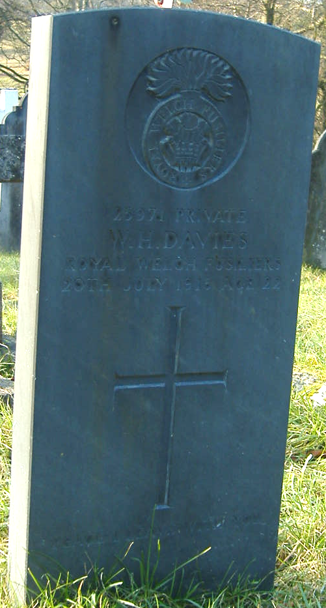
William Henry Davies was born in Llantysilio in 1894, the son of R. Thomas Davies, a machine minder, at the slate quarry of No 3 Maes y Llyn Cottages, Llantysilio, and Ellen Davies. Thomas Davies was also sexton at Llantysilio Church, where William became a choirister. William attended Llantysilio School, where he was taught by J. Jenkins, who later said how impressed he was with Williams thorough conscientiousness, he was not robust – and could have appealed for exemption from service on these grounds, considered it his duty to go. On leaving school he had become an under-gardener at Llantysilio Hall before becoming private 25971 with 17th Battalion Royal Welsh Fusiliers. He received shrapnel wounds during their advance in France in 1916, and was evacuated to Kings Hospital London, but died after a few days on 20th July 1916. The body was conveyed to Llangollen by train on the 25th and from there to Llantysilio by lorry, where he was given a full military funeral.
William Henry Davies, private, 25971
Royal Welsh Fusiliers, 17th Battalion
Died 20th July 1916, aged 22
Buried Llantysilio Churchyard
Son of Mr. R.T. and Mary Ellen Davies, of Abbey Terrace, Llangollen

28th July 1916
DIED OF WOUNDS
Davies, Pte. Henry, Royal Welsh Fusiliers.
Pte. Davies, who died of wounds (received in action during the great advance in France, in a London Hospital, was a son of Mr. Thomas Davies, sexton, Llantysilio Church.

Military Funeral at Llantysilio.
News of the death of Pte. William Henry Davies, R.W.F., which occurred as the result of wounds sustained during the great advance in France, at the King’s Hospital, London, caused profound feelings of sorrow in the Llangollen district. Young Davies was a youth of great promise (he had barely completed his twenty-second year when he fell) and our correspondent, who sought his old schoolmaster, Mr. J. Jenkins, at Llantysilio Schools, was favoured with a keenly appreciative eulogy of the gallant young soldier. “I was always,” said Mr. Jenkins, “impressed by his thorough conscientiousness. In this affair he saw it was his duty to go and he went. He was not robust – on these grounds he might have appealed for exemption – but he did not belong to that breed. Not one of the strongest and the most vigorous, the fires of patriotic enthusiasm burned in him brightly and he went.” “God knows,” said Mr. Jenkins, “how much we at the old school deplore his loss; but God also knows we would not have a shirker amongst us at Llantysilio if we could order things.”
When young Davies joined up he was engaged as undergardener at Llantysilio Hall; his parents being Mr. and Mrs. Thomas Davies, of Maesllyn. He took part with his regiment in the great advance where he received the wounds that proved fatal. It is a noteworthy fact that three other men from Llantysilio were in the charge when he fell – Pte. Ed. L. Lloyd (who was wounded). Pte. Thomas Roberts Llandinan and Pte. Thomas Jones, Maesllyn. From France he was conveyed to the King’s Hospital, London, and here he lingered for several days, the injuries from shrapnel only leaving one issue possible. After his death, it was decided that interment should be made at Llantysilio churchyard which he knew and loved so well; his father being sexton at the historic old church, where the son had been a member of the choir and a very valued worker. The remains were conveyed by rail to Llangollen on Tuesday afternoon and there was a large gathering of the general public at the station when the coffin arrived. Mr. Hawthorne, himself a prominent member of the choir at Llangollen Church, had made arrangements for the funeral; an open lorry, decorated with evergreens and draped with Union Jacks, being in waiting at the arrival platform. A firing party from the depot of the R.W.F. at Wrexham, was in attendance; and the bugle brigade of the Liverpool Church Cadet Corps., now in camp at Llangollen, also lined up at the station entrance. Headed by the Royal Welsh, with arms reversed, the cortege passed through the crowds of bare-headed sympathisers, to Llantysilio. Those who followed the mournful cortege included Messrs. J. Jenkins (the old schoolmaster of the deceased), A. Davies, E. Davies (Llantysilio), J. Seed (Llantysilio), W. Thomas, H. Thorne, R. Morris, E. Rogers (Berwyn), R. Parry, Hawthorne, Higginson, and Jas. Evans (Maesllyn). At Pentrefelin, the mournful procession was joined by the brother of the deceased, Mr. George Davies (brother), and Mr. Stephen Windsor, and from here they proceeded, through a torrential downpour of rain, to Llantysilio. The service was choral, the Vicar, the Rev. Aeron Davies, officiating in the church and subsequently at the graveside. The interior of the little church was crowded to its utmost capacity by those who in life had known and admired the young hero. At the grave the firing party discharged volleys over the resting place of the deceased; and the bugle band of the Liverpool Cadets sounded the “Last Post.” Many beautiful wreaths were placed upon the grave having been sent, amongst others, from Llantysilio National School, “ In loving memory of W. H. Davies from the pupils with heartfelt sympathy and conscious pride.
He played the man, he fought the fight,
As British soldiers always do;
Stood up for right against cruel might
A Christian hero, brave and true.”
Amongst others who attended at the Church were Mrs. Harrison, Bryntysilio Hall; Mrs. Davies and Miss Chaplain, the Vicarage.

1901 No 3 Maes y Llyn Cottages
Thomas Davies Head M 34 Machine Minder, Slate Quarry Llantysilio
Ellen Davies wife M 33 Llantysilio
William Henry Davies son S 9 Llantysilio
Frank Davies son S 2 Llantysilio
George Thomas Davies son S 6 mn Llantysilio

1911 58 Maes Y Llyn Cottages, Llantysilio Llangollen
Thomas Davies Head M 44(1867) Roadman Llantysilio Denbigh
Ellen Davies Wife M 43(1868) Llantysilio Denbigh
William Henry Davies Son S 17(1894) Gardener Domestic Llantysilio Denbigh
Frank Davies Son S 12(1899) School Llantysilio Denbigh
George Davies Son S 10(1901) School Llantysilio Denbigh
Nellie Jones Niece S 10(1901) School Llantysilio Denbigh

