6. William Owen Jones

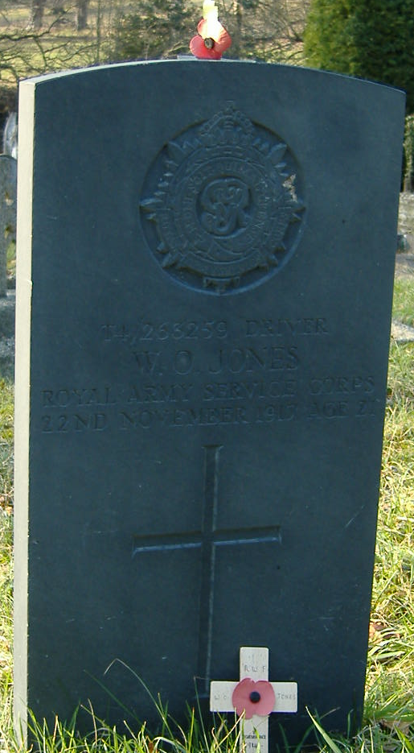
William Owen Jones was born 1897 in Llantysilio, son of John Jones, a slate quarryman of Llandynan Cottages, Llantysilio and Elizabeth Jones (possibly nee Owens). By 1911 William was a farm labourer, and the family were in No. 1, North End Cottage, Llantysilio, but he later worked in Mr. E.H. Lloyd’s Central Stores, Castle Street. He was one of nine men to join up from the Central Stores, becoming Driver T4/263259 with the 66th Division Train, Army Service Corp. In October 1917 he was gassed in France, and transferred to an auxiliary hospital in Liverpool, but he died on 22nd November, the fourth of the nine from the Central Stores to die. His body was returned to Brookside, Pentredwr, where his family now was, and was buried on the north side of Llantysilio Church yard on the 24th November 1917.

William Owen Jones, Driver, T4/263259
66th Division Train, Army Service Corp
died 22nd November 1917, aged 21 buried Llantysilio – north side
son of John and Elizabeth Jones, Brookside, Pentredwr.
1901 Llandynan Cottages, Llantysilio
John Jones head M 44(1857) Slab Quarryman Llangollen
Elizabeth Jones wife M 35(1866) Llantysilio
Deborah O Jones dau S 12(1889) Llantysilio
Mary Jones dau S 8(1893) Llantysilio
Ada Jones dau S 6(1895) Llantysilio
William Jones son S 4(1897) Llantysilio
Ivor Jones son S 1(1900) Llantysilio
1911 North End Cottage No1, Llantysilio
John Jones head M 54(1857) Quarryman Llangollen
Elizabeth Jones wife M 45(1866) M 23 y, 11 ch 4 die Llantysilio
Mary Jones dau S 18(1893) Dom serv Llantysilio
Ada Jones dau S 16(1895) Fountain pen maker Llantysilio
William Jones son S 14(1897) Farm serv Llantysilio
Ivor Jones son S 11(1900) Llantysilio
Lloyd Jones son S 6(1905) Llantysilio
Laura Jones dau S 3(1908) Llantysilio

30th November 1917

SOLDIER’S FUNERAL. – Impressive services were witnessed at Llantysilio on Monday when a very large number of relatives and friends attended the funeral of Pte. William Jones, A.S.C., late of Brookside, Pentredwr, who had been an inmate of the auxiliary hospital for three weeks, having been gassed in France some four weeks ago, and who died on Thursday, his body being conveyed home on Saturday. A short service was conducted at the house by the Rev. George Griffiths and at the Church, at Llantysilio, by the Vicar. Deceased was formerly employed at Mr. E.H. Lloyd’s Central Stores, and was one of nine men to join up from the establishment, and the fourth who has died for King and country.

22nd November 1918
IN REMEMBRANCE.
JONES. – In ever loving memory of Willie, the dearly loved eldest son of John and Elizabeth Jones, who died at Liverpool from gas poisoning, Nov. 22nd 1917, aged 21 years. – Never forgotten by father, mother, brothers, and sisters, Brookside, Pentrdwr, Llangollen.
You gave your life, you did your best,
May God grant you eternal rest.

